**Task 3**

**Project: Event Management System using PostgreSQL**

**Objective: To develop the application that allows users to create and manage events, track attendees, and handle event registrations efficiently. The project will include the following tasks:**

**1. Database Creation**

**Create a database named "EventsManagement."**

**Create tables for Events, Attendees, and Registrations.**

**Events-Event_Id, Event_Name, Event_Date, Event_Location, Event_Description**

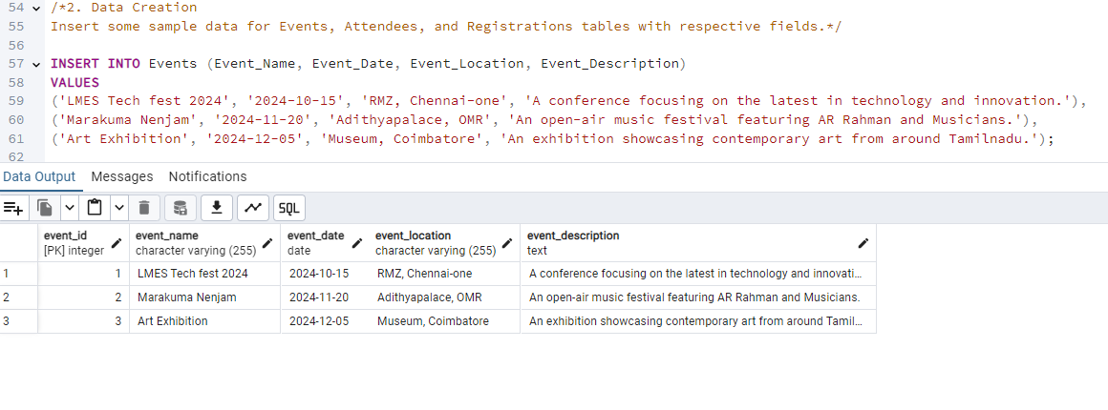

**Attendees-Attendee_Id, Attendee_Name, Attendee_Phone, Attendee_Email, Attendee_City**

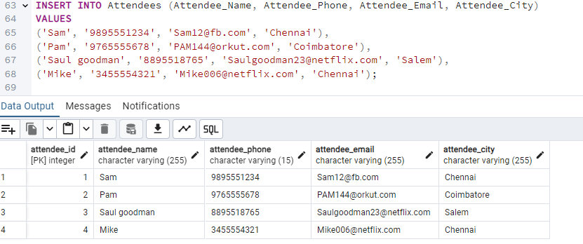

**Registrations-Registration_id, Event_Id, Attendee_Id,Registration_Date, Registration_Amount.**

**The FOREIGN KEY constraint in the Registrations table references the Event_Id column in the Events table and the Attendee_Id column in the Attendees table.**

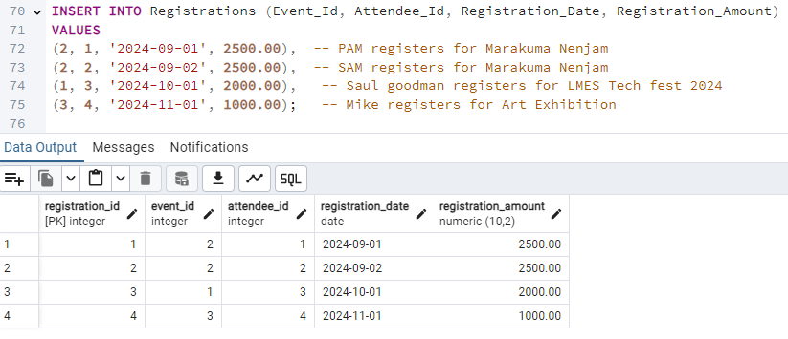

**2. Data Creation**

**Insert some sample data for Events, Attendees, and Registrations tables with respective fields.**

INSERT INTO Events (Event_Name, Event_Date, Event_Location, Event_Description)

VALUES

('LMES Tech fest 2024', '2024-10-15', 'RMZ, Chennai-one', 'A conference focusing on the latest in technology and innovation.'),

('Marakuma Nenjam', '2024-11-20', 'Adithyapalace, OMR', 'An open-air music festival featuring AR Rahman and Musicians.'),

('Art Exhibition', '2024-12-05', 'Museum, Coimbatore', 'An exhibition showcasing contemporary art from around Tamilnadu.');

INSERT INTO Attendees (Attendee_Name, Attendee_Phone, Attendee_Email, Attendee_City)

VALUES

('Sam', '9895551234', 'Sam12@fb.com', 'Chennai'),

('Pam', '9765555678', 'PAM144@orkut.com', 'Coimbatore'),

('Saul goodman', '8895518765', 'Saulgoodman23@netflix.com', 'Salem'),

('Mike', '3455554321', 'Mike006@netflix.com', 'Chennai');

INSERT INTO Registrations (Event_Id, Attendee_Id, Registration_Date, Registration_Amount)

VALUES

(2, 1, '2024-09-01', 2500.00), -- PAM registers for Marakuma Nenjam

(2, 2, '2024-09-02', 2500.00), -- SAM registers for Marakuma Nenjam

(1, 3, '2024-10-01', 2000.00), -- Saul goodman registers for LMES Tech fest 2024

(3, 4, '2024-11-01', 1000.00); -- Mike registers for Art Exhibition

select * from Events;

**/*3. Manage Event Details**

**a) Inserting a new event.*/**

INSERT INTO Events (Event_Name, Event_Date, Event_Location, Event_Description)

VALUES

('Annual amazon Bash 2024', '2024-12-15', 'Leela Palace, ECR, Chennai', 'Annual celebrations held for Amazon employees. The event will feature a dinner and entertainment.');

select * from events;

**-- b) Updating an event's information.**

UPDATE Events

SET Event_Location = 'WTC, OMR',

Event_Description = 'A conference focusing on the latest in technology and innovation (Focusing largely on LLM).'

WHERE Event_Id = 1;

SELECT * FROM EVENTS

WHERE EVENT_ID = 1;

**-- c) Deleting an event.**

SELECT * FROM Registrations WHERE Event_Id = 3; -- Checking for registered attentees in event id 3 (Mike registered for Art Exhibition)

DELETE FROM Registrations WHERE Event_Id = 3; -- deleted entry value for registered attentees in event id 3

DELETE FROM Registrations WHERE Event_Id = 3; -- deleted event id 3

select * from registrations;

**/*4) Manage Track Attendees & Handle Events**

**a) Inserting a new attendee.*/**

INSERT INTO Attendees (Attendee_Name, Attendee_Phone, Attendee_Email, Attendee_City)

VALUES ('Chuck', '9876543210', 'Chuck@HHMadvocates.com', 'Bangalore');

select * from Attendees;

**-- b) Registering an attendee for an event.**

INSERT INTO Registrations (Event_Id, Attendee_Id, Registration_Date, Registration_Amount)

VALUES (2, 5, '2024-09-15', 2500.00);

-- To display the added event.

SELECT

a.Attendee_Name,

e.Event_Id,

e.Event_Name,

e.Event_Date,

a.Attendee_Id,

r.Registration_Amount

FROM

Registrations r

JOIN

Events e ON r.Event_Id = e.Event_Id

JOIN

Attendees a ON r.Attendee_Id = a.Attendee_Id

WHERE

r.Event_Id = 2 AND r.Attendee_Id = 5;

**-- 5.Develop queries to retrieve event information, generate attendee lists, and calculate event attendance statistics.**

SELECT

e.Event_Id,

e.Event_Name,

COUNT(r.Attendee_Id) AS Total_Attendees

FROM

Events e

LEFT JOIN

Registrations r ON e.Event_Id = r.Event_Id

GROUP BY

e.Event_Id, e.Event_Name;